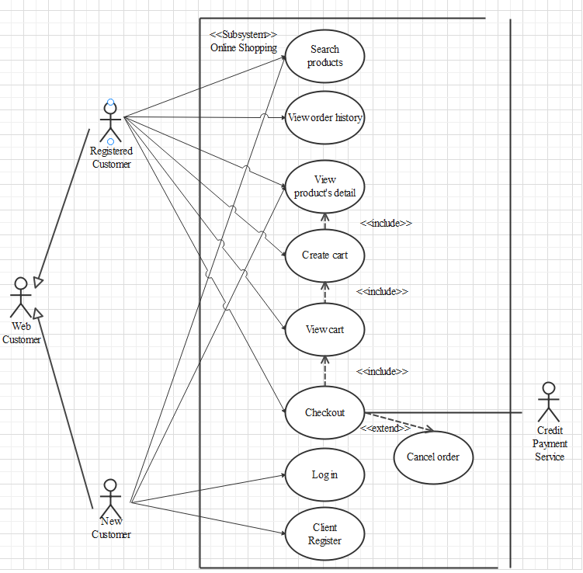

Search products

|  |  |  |
| --- | --- | --- |
| Author |  | |
| Use case name | Search product | |
| Actors | Guest/User | |
| Description | Guest/User can search product | |
| Requirements | Actor provides search phrase | |
| Pre-conditions | N/A | |
| Post-conditions | Success: Show product that matches search phrase | |
| Fail: No product is shown | |
| Basic flow | Actor’s actions: | System’s responses: |
| 1. Actor inputs search phrase 2. Actor clicks product’s name in list or view every product that matches search phrase. | 1. System shows list of products that match the search phrase |

View product detail

|  |  |  |
| --- | --- | --- |
| Author |  | |
| Use case name | View product | |
| Actors | Guest/User | |
| Description | Guest/User can view product detail | |
| Requirements | Actor select product to show product’s detail | |
| Pre-conditions | N/A | |
| Post-conditions | Success: Display product detail matching the selected product | |
| Fail: No product is shown | |
| Basic flow | Actor’s actions: | System’s responses: |
| 1. Actor select product | 1. System shows product’s detail matching selected product |

Create cart

|  |  |  |
| --- | --- | --- |
| Author |  | |
| Use case name | Create cart | |
| Actors | Guest/User | |
| Description | Guest/User can add product to their cart | |
| Requirements | Actor must choose at least one product | |
| Pre-conditions | Actor must log in before adding product | |
| Post-conditions | Success: Actor add product to cart successfully | |
| Fail: Refill information | |
| Basic flow | Actor’s actions: | System’s responses: |
| 1. Actor chooses a product and click “Add to cart”. | 2. System adds selected product to cart by product_id |
| Alternative flow |  |  |
| Exceptions | Actor’s action | System’s response |
|  | 1. Actor inputs more products than there are in stock. | System shows messages:   * “Product out of stock”. |

View cart

|  |  |  |
| --- | --- | --- |
| Author |  | |
| Use case name | View cart | |
| Actors | Guest/User | |
| Description | Guest/User can view their cart | |
| Requirements |  | |
| Pre-conditions | Actor must log in before view cart | |
| Post-conditions | Success: Actor can view their cart | |
| Fail: Refill information | |
| Basic flow | Actor’s actions: | System’s responses: |
| 1. Actor click on “Cart” icon. | 2. System shows cart and added products. |
| Alternative flow | 1. Actor clicks “Go back to shopping”  3. Actor clicks “X” button on each product. | 2. System redirects to product page.  4. System removes product from cart. |

Checkout

|  |  |  |
| --- | --- | --- |
| Author |  | |
| Use case name | Check out and Place order | |
| Actors | Guest/User | |
| Description | Guest/User can order products | |
| Requirements | Actor must has at least 1 cart | |
| Pre-conditions | Actor must log in before adding product | |
| Post-conditions | Success: Actor order successfully | |
| Fail: Refill information | |
| Basic flow | Actor’s actions: | System’s responses: |
| 1. Actor chooses their cart and click “Checkout” button  3. Actor clicks “Process Order” button.  5. Actor inputs order information then click “Place Order” button.  7. Actor inputs Card owner’s name, card number and security code.  10. Actor views order’s status in Order page. | 2. System shows cart and added products.  4. System shows all products in cart with calculated total price  and show following controls:   * “Billing name” text field. * “Address” text field. * “Required date” * “Payment” checkbox.   6. Systems show Payment page if user chooses Pay with Card method.  8. System validates information.  9. System redirects to Order page and show order’s status. |
| Alternative flow | 1. Actor clicks “Go back to shopping”  3. Actor clicks “X” button on each product. | 2. System redirects to product page.  4. System removes product from cart. |
| Exceptions | Actor’s action | System’s response |
|  | 1. Actor input invalid voucher code.  2. Actor inputs more products than there are in stock.  3. Actor left “Billing name” text field blank.  4. Actor left “Address” text field blank.  5. Actor left “Required date” blank.  6. Actor left “Payment” checkboxes blank.  7. Actor inputs invalid card information. | System shows messages:   * “Invalid voucher”. * “Product out of stock”. * “Billing name must not be blank”. * “Address must not be blank”. * “Must choose a required date”. * “Must choose a payment method”. * “Invalid card”. |

Cancel order

|  |  |  |
| --- | --- | --- |
| Author |  | |
| Use case name | Cancel order | |
| Actors | User | |
| Description | User can cancel their order | |
| Requirements | Actor provides order’s id to cancel | |
| Pre-conditions | Actor must log in to website and only can cancel when this order has not been confirmed by admin | |
| Post-conditions | Success: Cancel successfully. | |
| Fail: Order cannot cancel. | |
| Basic flow | Actor’s actions: | System’s responses: |
| 1. Actor chooses Account Tab on Menu  3. Actor chooses Order Tab on sides bar.  5. Actor selects the order which they want to cancel in Order List and clicks Cancel Button. | 2. System redirects to Account page.  4. System redirects to Order List page and displays a list of existing orders.  6. System validates inputs.  7. System change order status in the database.  8. System displays message: successful for error. |

View order history

|  |  |  |
| --- | --- | --- |
| Author |  | |
| Use case name | View order history | |
| Actors | User | |
| Description | User can view their order history | |
| Requirements |  | |
| Pre-conditions | Actor must log in to website | |
| Post-conditions | Success: Actor can view their order. | |
| Fail: Actor cannot see their order. | |
| Basic flow | Actor’s actions: | System’s responses: |
| 1. Actor chooses Account Tab on Menu  3. Actor chooses Order Tab on sides bar.  5. Actor selects the order that they want to view in Order List and clicks “View” Button. | 2. System redirects to Account page.  4. System redirects to Order List page and displays a list of existing orders and theirs status.  6. System validates inputs.  7. System displays all order’s detail and its status. |